**The Battle of the Neighborhoods**

Identification of appropriate location for new Italian restaurant in Paris

May 2, 2020

1. **Introduction**
   1. **Background**

The study area of the project is Paris city, capital and most populous city in France. Paris is one of the main business cities in Europe, and with Brexit there are some possibilities that different headquarters will move from London to Paris. Developed economy and business activities with strong turism, all of these makes city very attractive for small and medium-sized enterprises.

This also means that market is very competitive. The high cost of living also increases the cost of business and makes it challenging. As a result, any business decision must be analysed carefully. Proper analytical work provides good understanding of the business environment and helps to identify targeting audience. This analysis also helps to reduce risks and find new opportunities for expansion and diversification.

* 1. **Business Problem**

This project will examine possible locations for setting up Italian restaurant in Paris. Restaurant is a business that prepares and serves food and drinks to customers. Meals are generally served and eaten on the premises, but many restaurants also offer take-out and food delivery services. Paris is famous for its diverse cuisines from different cultures. So it is significant to create accurate strategic plan to survive in such a high competitive market.

One of the main parametes in restaurant lanching is location. Once it is launched the most difficult to change is location, so this business plan step should be done carefully. If this step is successful, there will be new opportunities for other ventures in different locations. So, choosing location is very important step.

* 1. **Target Audience**
* Investors
* Businessmen interested in launching new restaurant
* Businessmen interested in expansion of existing restaurant chain

Target audience is restaurant management team, which hired me as Data Scientist to propose effective location for restaurant venture in Paris. As part of analytical work, data scientist should prepare argumentative report with final recommendations for the management team.

1. **Data acquisition and cleaning**
   1. **Data Sources**

In this project two main data sources will be used.

*Data 1*. In order to divide the region into smaller clusters, it was decided to use metro stations as centers for neighborhood analysis. The region of Il-de-France has 25,338 metro stations. For every metro station the data for location, including latitude and longitude is required. This information is gained from RATP, official information website for Paris metropolitan users.

* This dataset exists for free on the web. Link to the dataset is :

[https://dataratp2.opendatasoft.com/](https://dataratp2.opendatasoft.com/4)

*Data 2*. Il-de-France (Paris city) geographical coordinates data will be used as input for the Foursquare API, that will be leveraged to provision venues information for every communes. We will use the Foursquare API to explore different business activities with detailed information such as name, category, location, responces and others.

* This dataset exists for free on the web. Link to the dataset is : <https://foursquare.com>
  1. **Data Cleaning**

Downloaded dataset for metro station location had some problems, it was not usable for further analysis by pandas. Firstly, coordinates for each station, latitude and longitude, were given in one cell in string. So, these data were spited and put in new columns called ‘Latitude’ and ‘Longitude’, and values were changed into float.

Secondly, description of the stations included some text and post code of the location. So, this text was removed, and only post code remained. Using these post codes, the dataset was decreased, and only metro stations located in Paris city remained.

After that, stations were grouped by names using mean. This helped to combine stations with similar names but different directions and locate them between each other. This resulted in 1140 stations.

Such size of dataset was too large for further exploration using Foursquare API. So, to decrease the number of stations for future analysis outliers were removed as shown below.

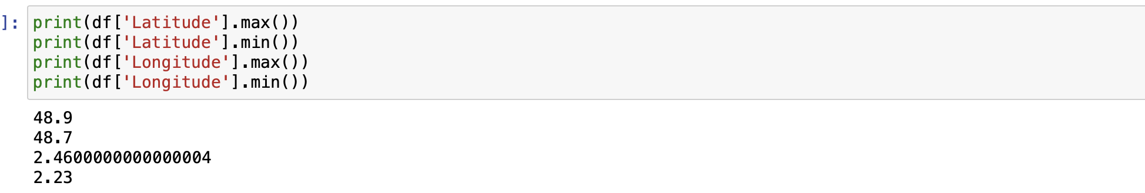



Figure 1. Removing outlier stations

This operation helped to decrease the number of stations to 481. Resulted dataset was ready for analysis using Foursquare API.

1. **Foursquare API**

Using geopy library we get latitude and longitude values of Paris. In order to do that, a user agent that was named PAR_explorer was used.

* The geographical coordinate of Paris are 48.8566969, 2.3514616.

After that, using Follium visualization library map of Paris with stations from dataset superimposed on the top was created.

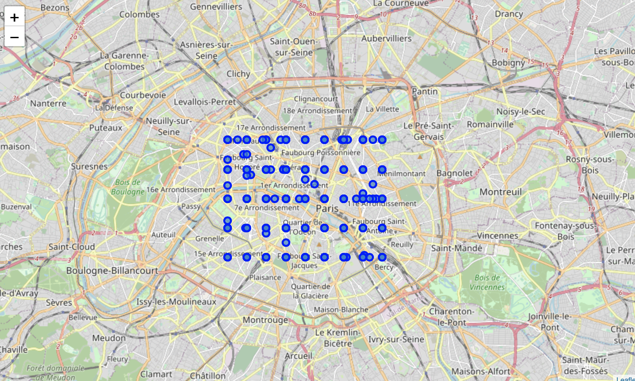

Figure 2. Location of stations on map

Now, in order to explore the neighborhood of the stations Foursquare API was utilized using following parameters:

* CLIENT_ID = Foursquare ID
* CLIENT_SECRET = Foursquare Secret
* VERSION = ‘20200310’
* LIMIT = 50
* Radius = 150
* categoryId = ‘4d4b7105d754a06374d81259’

Since stations are located close to each other, the radius of neighborhood venues was installed as 150 meters with limit in number of venues 50. Also, to decrease the number of output venues and to target competitive venues ‘Food’ category was added.

Table 1. Output table from Foursquare API call

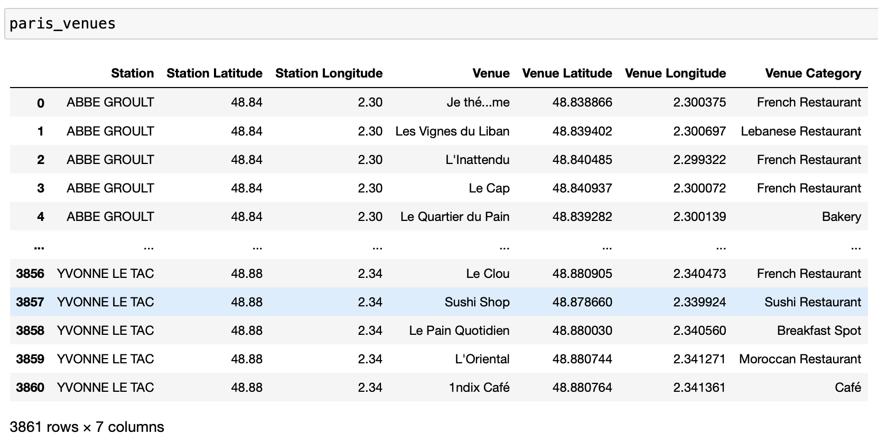

One problem with that table is that some venues are shown multiple times for different stations. So, checking ‘Venue’, ‘Venue Latitude’ and ‘Venue Longitude’ columns, duplications were removed.

After that pivot table with columns representing ‘Venue Category’ and rows representing ‘Stations’ was constructed. For better understanding of each station this pivot table was grouped by ‘Station’ using mean.

Table 2. Pivot table ‘Station’ vs ‘Venue Category’ grouped using mean

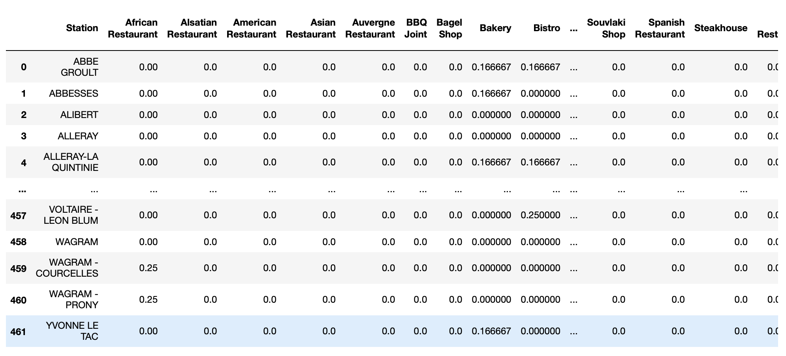

From pivot table demonstrated above, for each station only 10 most common venue categorized were chosen using coefficients (values) in that pivot table.

Table 3. Pivot table with Most Common Venues for Stations

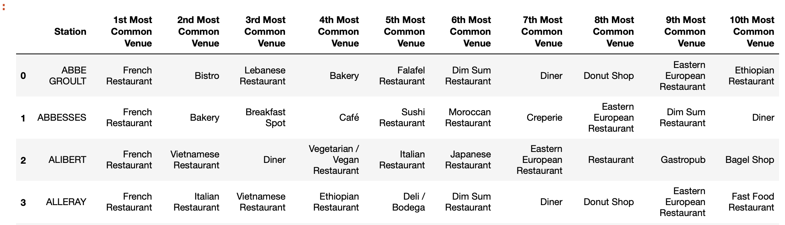

1. **Clustering**

On the table above it can be seen, that there are stations that have similar categories. As a result, one of the most popular unsupervised learning K-means algorithm was used to cluster stations. In our case, k-means method was used to divide the stations into 5 clusters. The stations in each cluster are similar to each other in terms of venue types located nearby.

Table 4. Stations with Cluster Labels

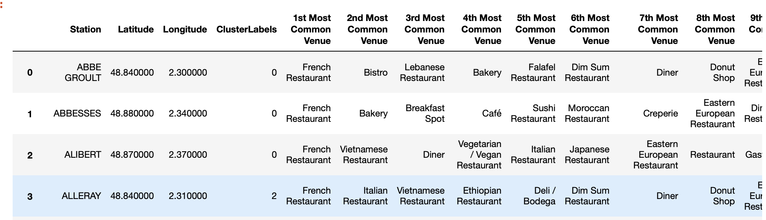

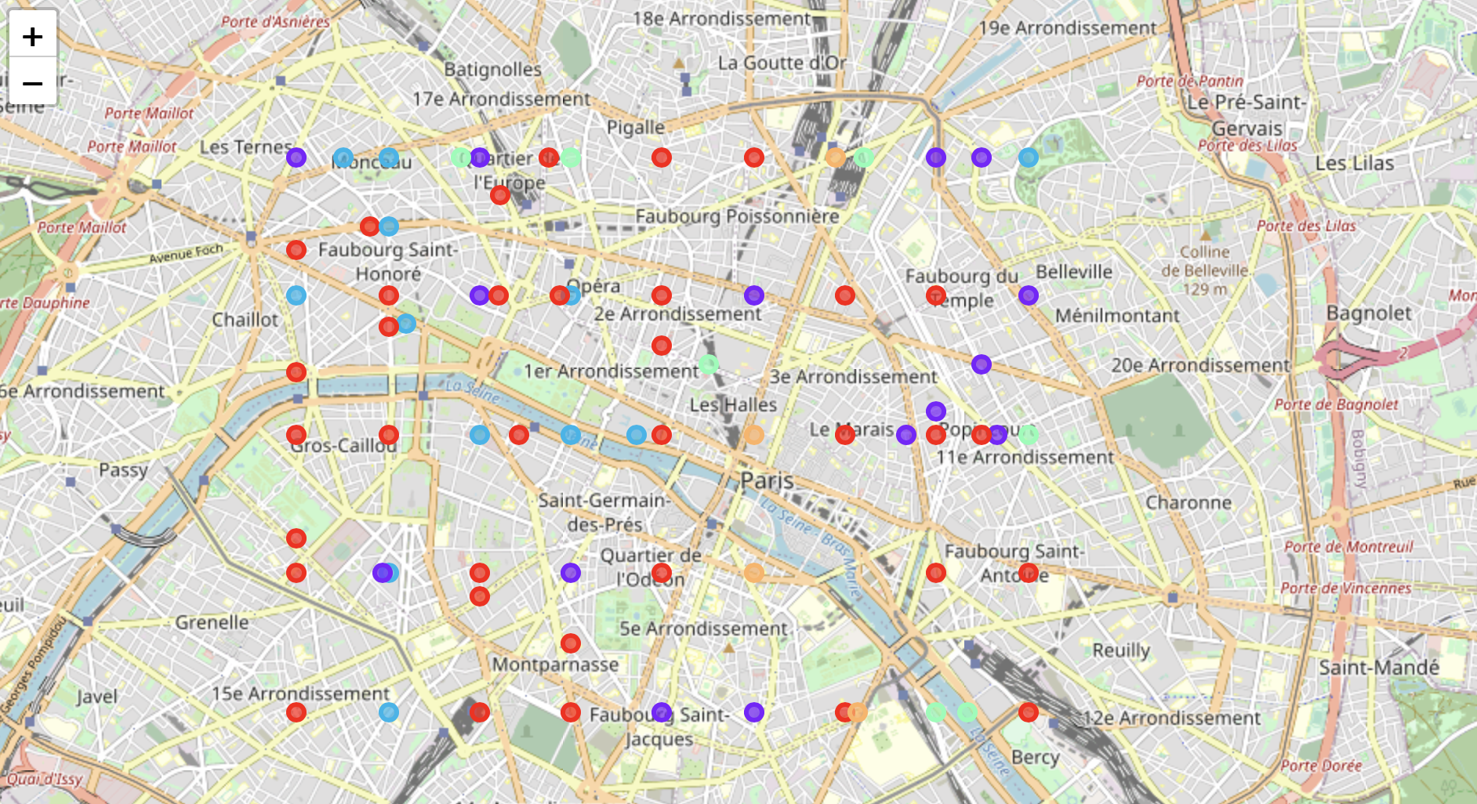

Figure 3. Stations after clustering

Red color – Cluster 0

Violet color – Cluster 1

Blue color – Cluster 2

Green color – Cluster 3

Orange color – Cluster 4

1. **Discussion**

After gaining clusters, each cluster can be examined deeper and some cluster categorizing venues can be identified.

* Cluster 0: Total number – 35

Table 5. Cluster 0

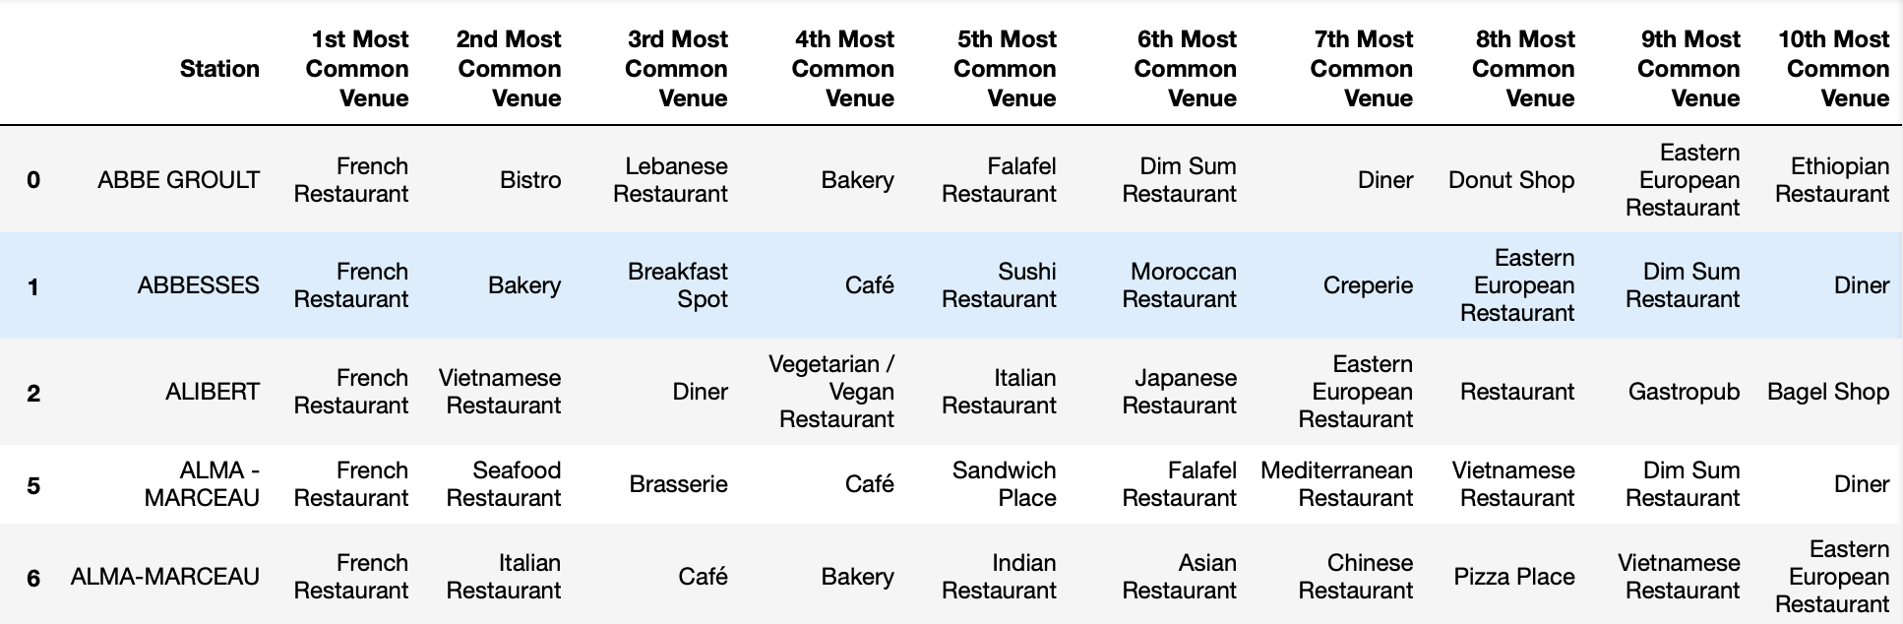

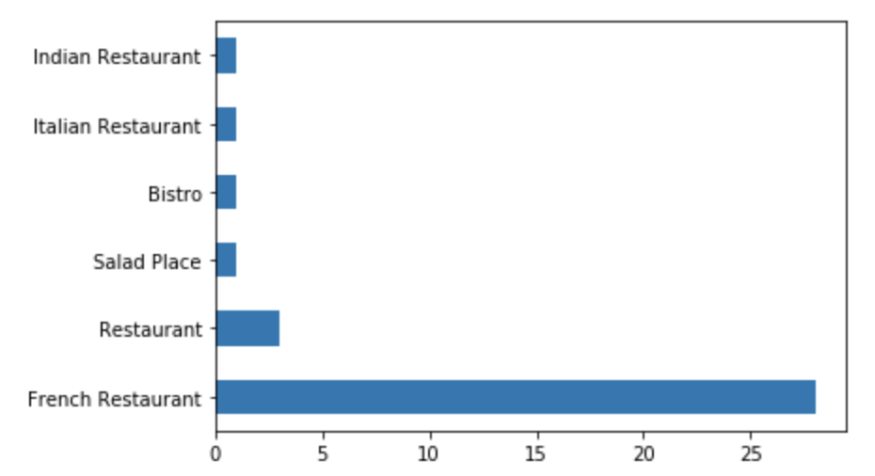

Figure 4. Venue categories count in Cluster 0

As it can be seen from the table and figure above, this cluster is mainly associated with French Restaurant.

* Cluster 1: Total number – 15

Table 6. Cluster 1

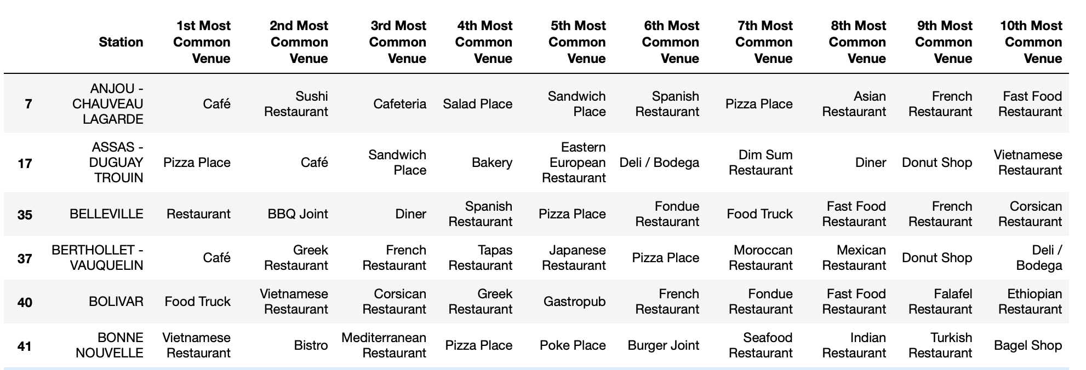

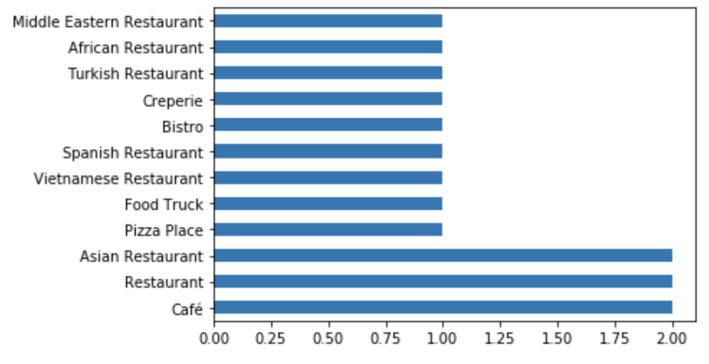

Figure 5. Venue categories count in Cluster 1

In this cluster, there are no specific venue category. Different cuisines are presented in this cluster, however some pattern for eastern and African restaurants can be noticed.

* Cluster 2: Total number – 12

Table 7. Cluster 2

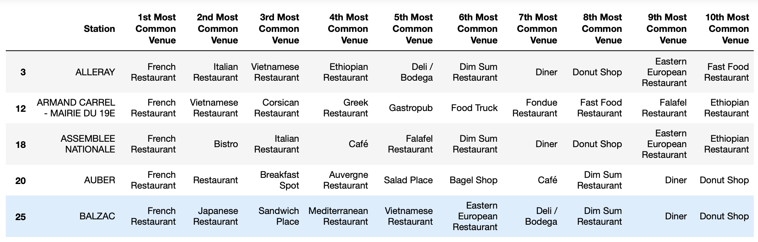

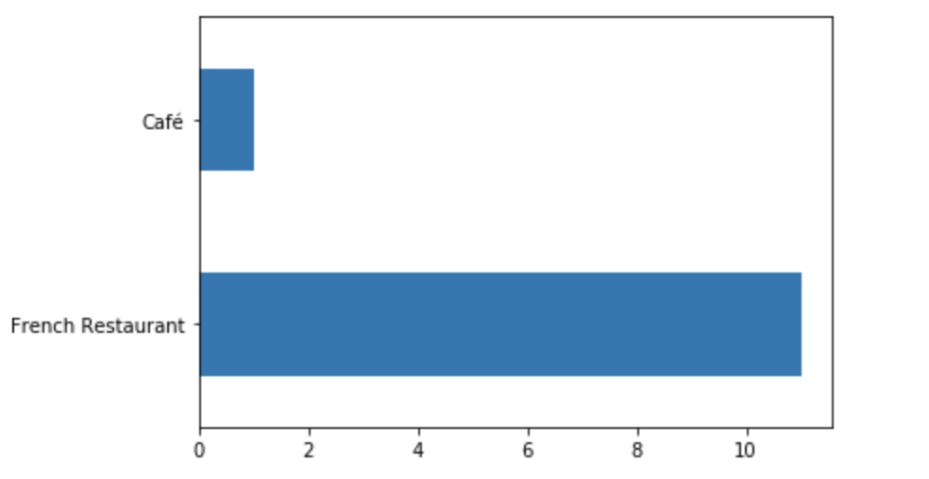

Figure 6. Venue categories count in Cluster 2

Here we can see that French restaurants are common in this cluster as in cluster 0. So, to get better understanding of difference, cluster 2 was deeper examined. Counting 2nd and 3rd most common venues demonstrated that along with French restaurants, Vietnamese restaurants are also popular in this cluster.

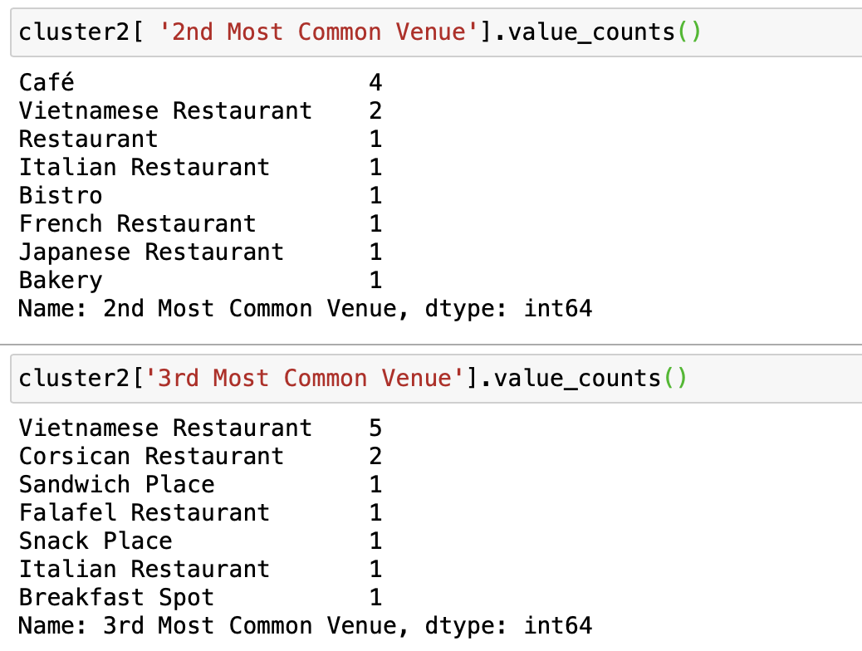

Figure 7. 2nd and 3rd most common venue categories count in Cluster 2

* Cluster 3: Total number – 7

Table 8. Cluster 3

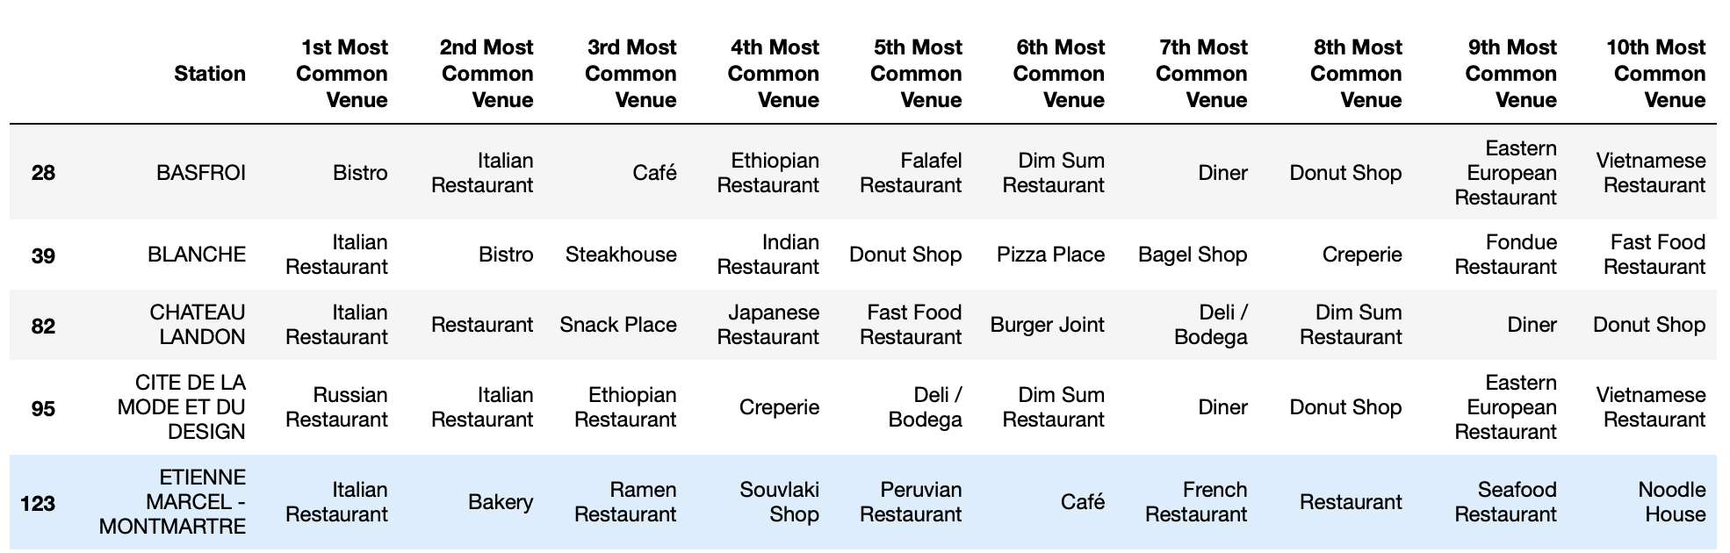

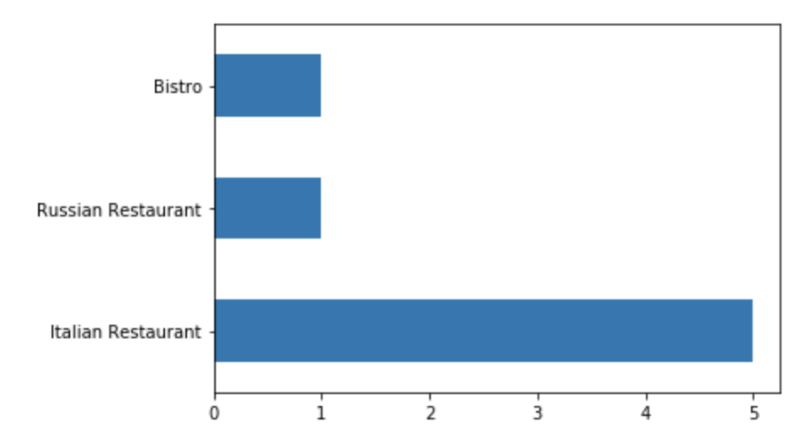

Figure 8. Venue categories count in Cluster 3

Cluster 3 is place where Italian restaurants are densely concentrated. As shown on the table and figure above stations in this cluster, mostly have 1st most common venue – Italian Restaurant. Even only two exceptions have Italian restaurants as 2nd most common venue.

* Cluster 4: Total number - 4

Table 9. Cluster 4

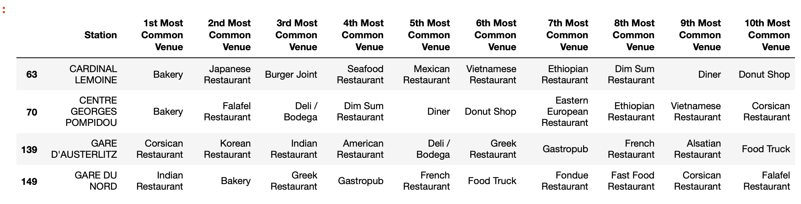

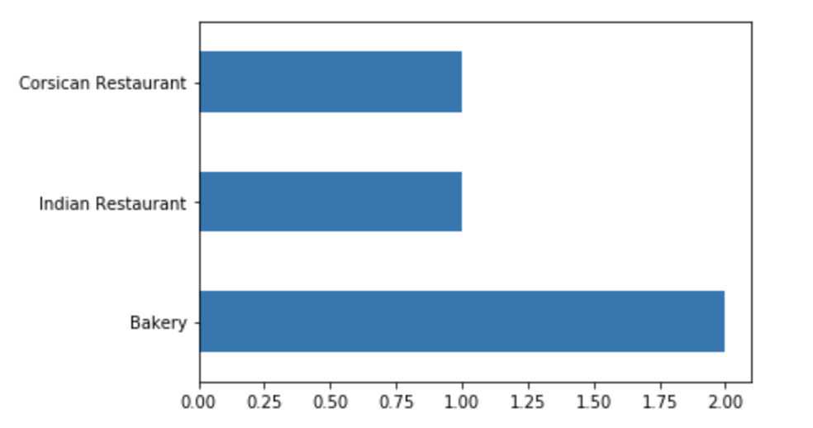

Figure 9. Venue categories count in Cluster 4

1. **Conclusion**

Based on the analysis information above, we can give some recommendations for possible Italian restaurant set up location. Firstly, cluster 3 station’s location should be deeply examined. May be such concentration if Italian restaurants can be explained by Italian district, which is actually a perfect location for our restaurant in case if there are still uncovered demand for such cuisine.

Another suggestion is to choose location far from cluster 3, which is related to Italian restaurant. As it can be seen from the map above, south-west part of the city doesn’t have Italian restaurant clusters, so in that part of the city it will be easier to locate Italian restaurant successfully.